= Monitor Calibration
Calibrating my monitor (an Iiyama Prolite H481S) I had quite a hard time - as I was totally clueless how to find proper settings.
http://www.normankoren.com/makingfineprints1A.html was a start and also http://www.pcbypaul.com/software/monica.html helped - especially providing a sensible test image.
I followed the advice of normankoren and decided to set the monitor back to factory settings and use the „NVIDIA X Server Settings“ tool to do the adjustments.
I did the following - having the screenshot (see below) displayed in 1:1 scale: * set color temperature to „s“ (the monitor manual says that's sRGB) * adjust brightness, so that a dark grey square became just visible within the black square * adjust contrast until the difference between the darkest two areas matched approximately the difference between the lightest two areas * very carefully re-adjust brigthness and contrast a bit to improve the two criteria above * adjust gamma, so that „line 693“ in the screenshot has a light blue background * voila!
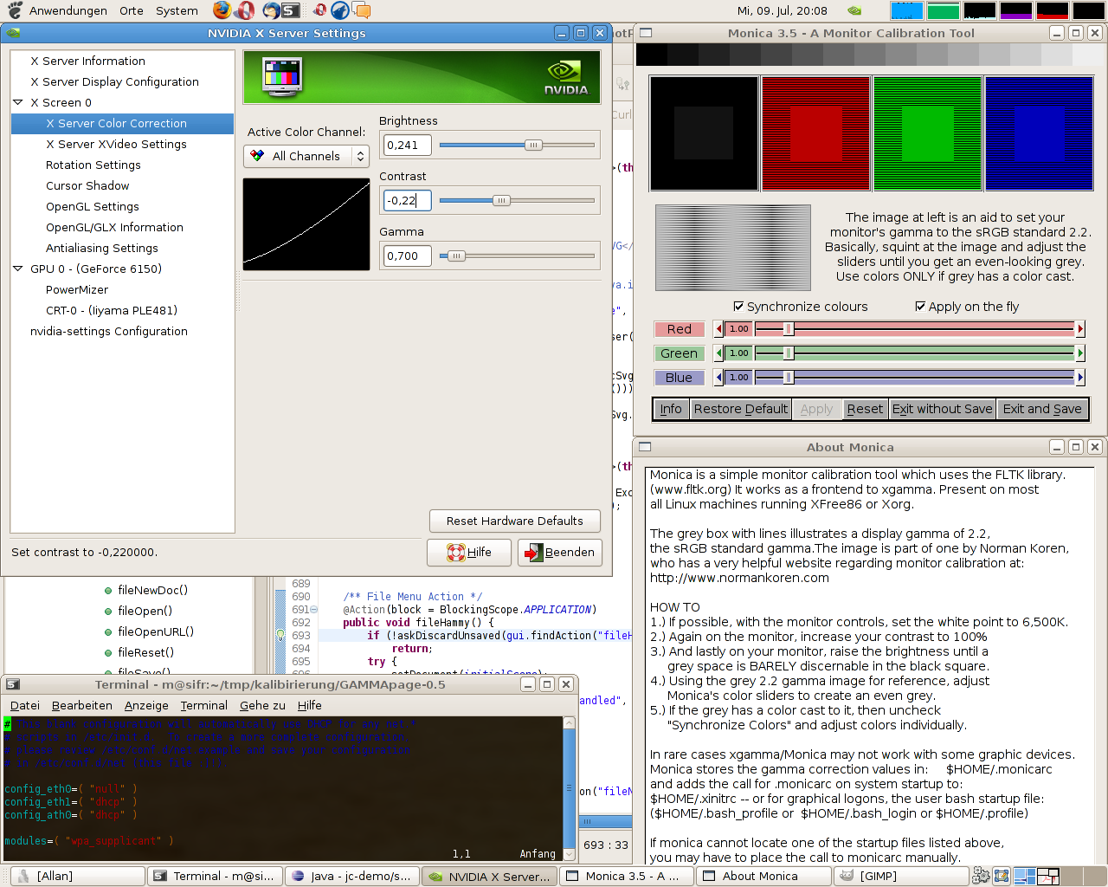Calibration Test Image and final Settings
Settings that seem to be ok for me are
Brightness Contrast Gamma
Red: 0.428 -0.39 0.846
Green: 0.384 -0.36 0.790
Blue: 0.428 -0.39 0.749
with 7500 K ("2"):
Red: -0.15 -0.007 1.380
Green: -0.27 0.048 1.312
Blue: -0.15 -0.007 1.380
or
Red: -0.08 -0.33 1.380
Green: -0.41 0.116 1.986
Blue: -0.14 -0.12 1.380
or
Red: -0.06 -0.12 1.380
Green: -0.41 0.116 1.986
Blue: -0.14 -0.12 1.380

